Doc Writer: Pavan y Doc Date: Dec 16, 2015.

Application or System Name
Enrollment and De Enrollment confirmation to DRMS
General Overview
- This requirement is to send the enrollment complete/De Enrollment complete confirmation to ESB so that they can be orchestrated to DRMS for DRMS Enrollment and De-Enrollment.
- Outbound interface to send de-enrollment confirmation to iFactor
- Outbound Interface to Send Pending Enrollment for CE initiated DPP Enrollment.
- Batch/web interface process is acceptable depending on Vendor interface.
- Enrollment Information to be determined during systems workshops. Enrollment will require: Rate Change, Registration into DRMS of customer in program, & engagement of notification system to be active to trigger event notifications

DRMS Enrollment on DPP Enrollment completion in SAP

- The DPP program Enrollment (CPP or PTR) is initiated via Enrollment Vendor or CE user, it will be updated into the Program Enrollment table in SAP with a status of ‘Pending’.
- Every day after billing is finished, a batch job will process the Enrollment Pending records in the DPP Enrollment table and will perform the necessary steps to enroll the customers to DPP rate category as selected at the time of the enrollment request.
- Once this occurs, the status of these records are updated to ‘Completed’ in the DPP Program Enrollment table.
- As soon as the Enrollment Completion update happens for a record, the enrollment confirmation needs to be sent to DRMS in “End Device Service Request” in canonical format to trigger enrollment in their system.

DRMS De-Enrollment on DPP De-Enrollment completion in SAP

- Once the customer is de-enrolled from either of the DPP programs (CPP or PTR) in SAP, the de-enrollment confirmation will need to be sent to DRMS in “End Device Service Request” in canonical format to trigger de-enrollment at their end.
Enrollment Pending request confirmation
- Once the customer is enrolled by CE in DPP programs (CPP or PTR) in SAP, the pending enrollment confirmation will need to be sent to EV in “End Device Service Request” in canonical format to trigger Pending Enrollment at their end.

Technical Design:
Function Modules:
SAP Reconciliation Interface processing logic:
In this functionalist we send Enrollment update to DRMS.
It has two interface PO is the middleware and we can send the data to drms
- Go to transaction code ‘sproxy’ is an object navigator
Here go to Enterprise Services Browse we can see some Names (Source, SWCs, Packages, Namespaces, Object types and Objects) in Source go to ESR->SWCs->External-DPP 1.0->Namespace->Enrollment_Updates->objects.
Here we will find some service interfaces like SI_DPP_ EnrollmentUpdates_out.
Go to the Transaction code SE38 and the program <ZCS_DPP_PROCESS_ENROLLMENT> is used for process DPP Enrollment.
Here we are using different tables <ZTPGM_ENROLL> is an enrollment table <BUT000> Business partner data <FKKVT> is an Contract account header and <IFLOT>Functional Location table.
In Process DPP Enrollment first we are process the initialization and in GET_DATA we are getting the rate change data and get drms reprocessing data.

Form GET_RATE_CHANGE_DATA first we will check the rate change and get enrollment details checks for the error gets the installation data and finally validate the enrollment data.
Form GET_ENROLLMENT_DETAILS we are getting enrollment details from the table<ZTPGM_ENROLL>
SELECT * FROM ztpgm_enroll
INTO TABLE gt_enroll
WHERE zenrlbp IN s_bp
AND zenrlca IN s_ca
AND zpgm_type IN s_pgm
AND zenrl_reqdat LE lv_date
AND zenrlstatus EQ '001'
AND zenrlsdp IN s_sdp.
By using s_bp we can get the business partner number details and s_ca is used for Contract Account number and s_pgm is used for enrollment program type based on the Date and status .
To get installation details we will sort the enrollment to get the contract.
SELECT vertrag
contracthead
contractpos
crm_product
product_guid
FROM everh INTO TABLE gt_conthist
FOR ALL ENTRIES IN gt_contract
WHERE vertrag = gt_contract-vertrag
AND ab < sy-datum
AND bis > sy-datum.
By using the above selection statement we will get the contract history.
For validating data first we have to loop through the enrollment data and perform the eligibility and read the interface data.
Mapping Class<ZCL_ISU_SE_MAP_DPP_DRMS> create a method<MAP_DRMSUPDATE_OUT>
This method maps data from the enrollment request from the enrollment vendor.
Here we will get the enrollment data from the tables <ZTPGM_INT_DATA> and <ZTPGM_ENROLL> based on the correlation Id, Enrollment business partner number, and Enrollment contract Account number, Enrollment program type and enrollment requested date.

SELECT SINGLE * ##WARN_OK
INTO ls_int_data
FROM ztpgm_int_data
WHERE zcorrelid_ref = xy_appldata-pgm_int_data-zcorrelid_ref.
IF sy-subrc = 0.
SELECT SINGLE *
INTO ls_enroll
FROM ztpgm_enroll
WHERE zenrlbp = ls_int_data-zenrlbp
AND zenrlca = ls_int_data-zenrlca
AND zpgm_type = ls_int_data-zpgm_type
AND zenrl_reqdat = ls_int_data-zenrl_date.
ENDIF.
Consuming the new interface and implementing the method inside the proxy class to read from the proxy structure and update the DPP enrollment table field DRMS Enrollment status as success or failure based on the interface inputs. This can later be used by program management to check the DRMS enrollment status of DPP enrollment customers in SAP.
IF x_input-changed_end_device_service_req-reply-result = 'OK'.
* xy_appldata-pgm_enroll-zenrldrms_stat = '1'.
IF ls_enroll-zenrlstatus = '002'.
xy_appldata-pgm_enroll-zenrldrms_stat = '1'.
ELSEIF ls_enroll-zenrlstatus = '004'.
xy_appldata-pgm_enroll-zenrldrms_stat = '2'.
ENDIF.
xy_appldata-pgm_enroll-zdrms_dat = sy-datum.
ELSE.
* xy_appldata-pgm_enroll-zenrldrms_stat = '6'.
IF ls_enroll-zenrlstatus = '002'.
xy_appldata-pgm_enroll-zenrldrms_stat = '6'.
ELSEIF ls_enroll-zenrlstatus = '004'.
xy_appldata-pgm_enroll-zenrldrms_stat = '7'.
ENDIF.
xy_appldata-pgm_enroll-zdrms_dat = sy-datum.
ENDIF.
When zenrlstatus is ‘002’and zenrldrms_stat is ‘1’ then Enrollment complete in DRMS and enrollment complete in sap.
When zenrlstatus is ‘004’and zenrldrms_stat is ‘2’ then De-Enrollment complete in DRMS and De-Enrollment complete in sap.
When zenrlstatus is ‘002’and zenrldrms_stat is ‘6’ then Enrollment complete in DRMS and enrollment failed in sap.
When zenrlstatus is ‘004’and zenrldrms_stat is ‘7’ then De-Enrollment complete in DRMS and De-Enrollment Failed in sap.

System Diagram

Technical Parts Inventory
-------Name------- | ----Description---- | -----Location----- | ----Environment---
sproxy | Transaction Code |  | E2D
ZCL_ISU_SE_IMPL_DPP_DRMS | Class |  | E2D
ZCL_ISU_SE_MAP_DPP_DRMS | Class |  | E2D
ZTPGM_ENROLL | Table |  | E2D
ZTPGM_INT_DATA | Table |  | E2D

Dependent Parts Inventory
-------Name------- | ----Description--- | -----Location----- | ----Environment---
N/A | N/A | N/A | N/A

PO Interface Technical Design Documentation:
Overview
This interface shall facilitate enrollment updates for customers in DPP programs. The interface sends a request from SAP to the DRMS. This interface facilitates updates of enrollment statuses for customers in DPP programs. This enables the SAP to provide updated enrollment information to DRMS, which allows the DRMS to add and remove users from DPP programs
Interface | DPP Enrollment updates
Folder | DPP
ICO | | E2D | SI_DPP_EnrollmentUpdates_Out | |
Pattern | PROXY to SOAP (ECC to ESB)
Below are the interface details.
Sender Details:
Business System | E2D
Service Interface | SI_DPP_EnrollmentUpdates_Out
Namespace | http://ce.corp.com/xi/DPP/CS_INT_DPP_005/Enrollment_Updates
Receiver Details:
Business System | ESBCORPD2
Service Interface | SI_DPP_EnrollmentUpdates_In
Namespace | http://ce.corp.com/xi/DPP/CS_INT_DPP_005/Enrollment_Updates
Operation Mapping:
Name | none

Communication Channel Details

Sender Communication Channel
Name | sender_SAP_backend
Adapter | SOAP

Screenshot of Sender Communication Channel
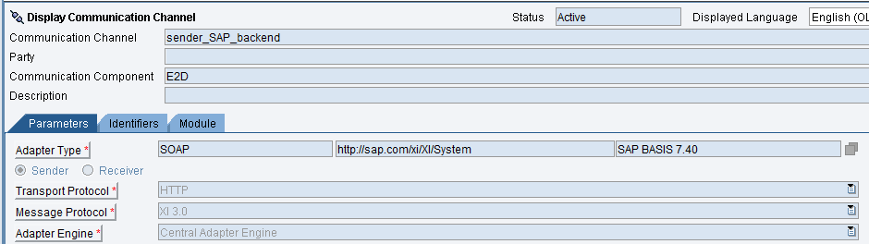

Receiver Communication Channel
Name | receiver_ESB_DPP_EnrollmentUpdates
Adapter | SOAP

Screen Shot Receiver Communication Channel
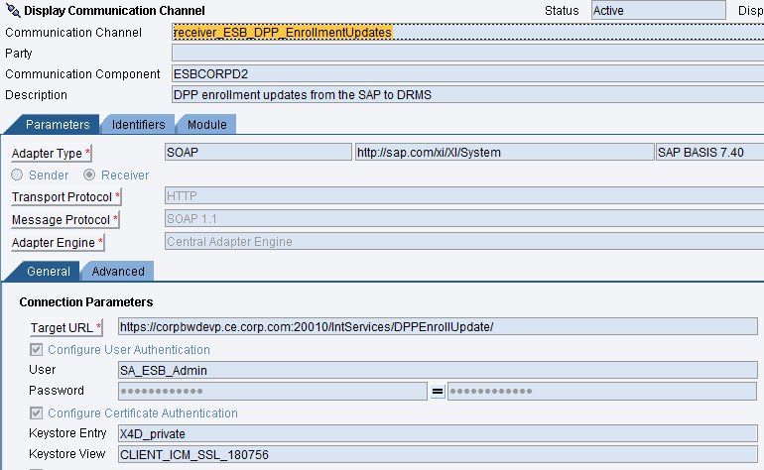
Message Mapping
No Mapping Objects exist as the Outbound and Inbound Service Interfaces use structures from same WSDL definition.

Revision History
Version | Author(s) | Date | Significant Changes
1.0 | Ed Abranovich | 01/06/15 | Approved Baseline Work Product
0.1 | Pavan y | 12/16/15 | Initial Document Release

